Coins if you know about the binomial distribution ...

If you spin a coin 20 times, what is the probability you get 10 heads and 10 tails?
Let X be the number of heads in 20 spins
X has a binomial distribution.
So:

In general:
If you spin a cointimes, what is the probability you getheads andtails?
Let X be the number of heads inspins
X has a binomial distribution.
So:

What happens ifis large?
Stirling discovered a remarkable approximation forwhenis large:
It is:
what areanddoing? See Footnote
Using Stirling’s approximation show that:
Ifis large then:

Footnote:

So:

Here is the graph

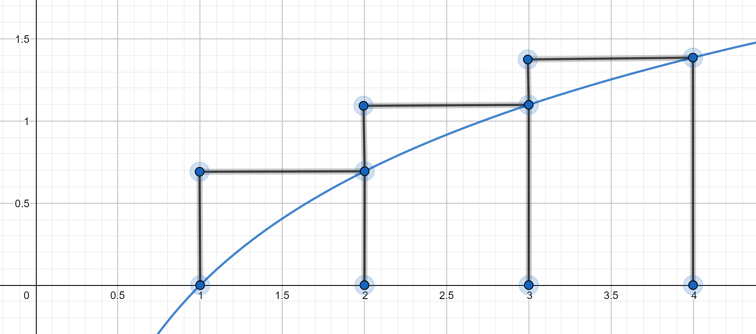

The diagram shows blocks betweenand

The area of the blocks is:

The area under the graph is:
So:

In general:
The diagram shows blocks betweenand

The area of the blocks is:

The area under the graph is:
So:

So:

Show that:

This is not as good as Stirling’s approximation but it’s a start.

